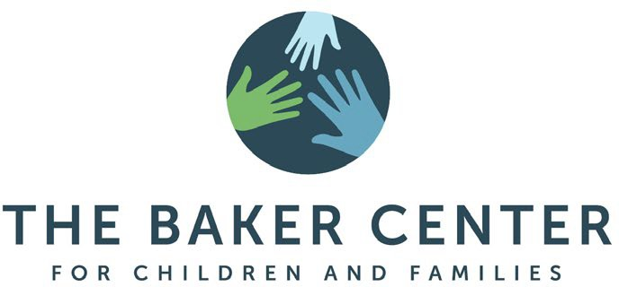

Clinical Postdoctoral Fellowship in Evidence-Based Youth Psychotherapy

# Summary

The Baker Center for Children and Families (previously Judge Baker Children’s Center), a Harvard Medical School Affiliate, is accepting applications for a clinical postdoctoral fellowship position at the Center for Effective Therapy (CET), the outpatient mental health clinic at The Baker Center for Children and Families. CET at The Baker Center provides mental health assessments and focused short-term treatments for approximately 500 children and adolescents ages 2-22 and their families annually. CET promotes the best possible mental health of children by using scientifically proven treatments in the assessment and treatment of children and families of diverse communities. Therapists utilize evidence-based treatments for some of the most common presenting problems including anxiety, depression, traumatic stress, and disruptive behavior. CET also trains mental health professionals in our treatment models to increase the quality of care throughout our communities. We expand public awareness and inform public policy through the use of research, data, and advocacy with local child and adolescent organizations.

The postdoctoral fellow will deliver direct outpatient services to children and adolescents experiencing difficulties with anxiety, depression, traumatic stress, disruptive behavior, and other emotional and behavioral problems. The postdoctoral fellow will receive training and supervision in evidence-based models for child and adolescent assessment and psychotherapy, including potential certification in Parent-Child Interaction Therapy (PCIT) and/or the Modular Approach to Therapy for Children with anxiety, depression, trauma, or conduct problems (MATCH-ADTC). The postdoctoral fellow will also assist the Senior Director of Outpatient Clinical Services in outreach activities to community organizations, school districts, and pediatricians. Additionally, the postdoctoral fellow will assist with program development of additional clinical service lines (e.g., group programming). Applicants will receive supervision consistent to meet Massachusetts psychology licensure requirements in the course of the fellowship year. Appointment as a fellow at Harvard Medical School is available for the qualified successful applicant.

# Essential Duties and Responsibilities

* Conducting semi-structured assessments of children ages 2-22 using the K-SADS diagnostic interview.
* Maintaining a diverse caseload of approximately 22 child and adolescent clients.
* Providing evidence-based treatment to children and families (e.g., MATCH, PCIT, TF-CBT).
* Working with caregivers to enhance the efficacy of treatment services.
* Using progress monitoring tools to assess efficacy of treatment and adjust intervention strategies as needed.
* Collaborating with collateral contacts in the best interest of clients.
* Co-supervising graduate and undergraduate level trainees.
* Assisting with outreach activities to multiple community partners (e.g., school districts, pediatricians).

# Qualifications and Skills

Candidates must meet all of the following requirements:

* Applicants must have completed a Ph.D. / Psy.D. / Ed.D. (or foreign equivalent) in Clinical, Counseling, or School Psychology from an accredited academic program.
* Completion of an APA- or CPA-approved internship.
* Clinical training and experience in CBT for childhood depression, anxiety, post-traumatic stress, and/or behavioral parent training for childhood disruptive behavior disorders.

53 Parker Hill Ave. 617-232-8390

Boston, MA, 02120 bakercenter.org

Strong applicants will have:

* Experience supervising or training clinicians in evidence-based methods.
* Experience giving professional presentations.
* Excellent interpersonal, organizational, and communication skills.
* Strong computer skills.

# Compensation

Compensation is competitive and based on experience. A generous benefits package is provided.

# Our Organization

Founded in 1917, The Baker Center for Children and Families is a Harvard Medical School affiliate with proven leadership in children’s behavioral health. The Baker Center’s mission is to promote the best possible mental health of children through the integration of research, intervention, training, and advocacy. For over 100 years, The Baker Center has been instrumental in creating a continuum of care that supports children's healthy development at the policy, systems, and practice levels. Our research, direct programs and services, training, and advocacy make The Baker Center a preeminent voice and active resource on issues of children's mental health. At The Baker Center, the practices created and tested today will become the best practices of tomorrow. Our programs help children and families chart their own best course for developmental, emotional, and intellectual well-being in community-based settings.

The Baker Center for Children and Families is dedicated to the achievement of equality of opportunity for all its employees and applicants for employment without regard to race, color, religion, sex, sexual orientation, marital status, age, national origin, disability, veteran status, or any other protected group status under federal, state, or local law. The Baker Center for Children and Families is an Equal Opportunity/Affirmative Action Employer.

The preceding statements shall not be considered a detailed description of all the work requirements of the job. There may be other duties and responsibilities required to achieve the principal functions of the position and to advance the mission of The Baker Center for Children and Families.

# Applications

Interested candidates should send

* A cover letter specifically addressing your experience related to the job responsibilities above
* A curriculum vitae
* Two (2) letters of recommendation emailed directly from your writer to [training@bakercenter.org](mailto:training@bakercenter.org)
* A de-identified assessment report (e.g., psychodiagnostic report, neuropsychological report)
* A de-identified treatment report (e.g., treatment plan, treatment summary)

to Sarah Tannenbaum, Psy.D., at [training@bakercenter.org.](mailto:training@bakercenter.org) In the title of your email, please reference “Clinical Postdoc Fellowship Application”.

**Application Deadline**: December 1, 2024

**Position Start Date:** July 1, 2025 with flexibility based on applicant availability